Name: | Vasundhara Singh
UID no.: | 2021700062
Experiment No. | 3
Class: | SE CSE(DS)
Batch: | D-4
Date of Experiment: | 27/02/2023

AIM: | Implement Divide and Conquer technique.
PROBLEM STATEMENT: | Implement Strassen’s Matrix Multiplication algorithm and compare it with standard matrix multiplication.
THEORY: | Strassen’s algorithm uses the divide and conquer technique in – divide matrix A & matrix B into 8 submatrices and then recursively compute the submatrices of C.  Consider the following matrices A and B:  A = |a b|, B = |e f| and we know A*B = matrix C = |ae+bg af+bh|  |c d| |g h| |ce+dg cf+dh|  There will be 8 recursive calls:  a * e  b * g  a * f  b * h  c * e  d * g  c * f  d * h  Using the Master Theorem with T(n) = 8T(n/2) + O(n^2) we still get a runtime of O(n^3).  But Strassen came up with a solution where we do not need 8 recursive calls but can be done in only 7 calls and some extra addition and subtraction operations.  Strassen’s 7 calls are as follows:  a * (f - h)  (a + b) * h  (c + d) * e  d * (g - e)  (a + d) * (e + h)  (b - d) * (g + h)  (a - c) * (e + f)  Our new matrix C’s new quadrants  matrix C = |p5+p4-p2+p6 p1+p2 |  |p3+p4 p1+p5-p3-p7|  p1 = a(f-h)  p2 = (a+b)h  p3 = (c+d)e  p4 = d(g-e)  p5 = (a+d)(e+h)  p6 = (b-d)(g+h)  p7 = (a-c)(e+f)  p5+p4-p2+p6 = (a+d)*(e+h) + d*(g-e) - (a+b)*h + (b-d)*(g+h)  = (ae+de+ah+dh) + (dg-de) - (ah+bh) + (bg-dg+bh-dh)  = ae+bg  p1+p2 = a*(f-h) + (a+b)*h  = (af-ah) + (ah+bh)  = af+bh  p3+p4 = (c+d)*e + d*(g-e)  = (ce+de) + (dg-de)  = ce+dg  p1+p5-p3-p7 = a*(f-h) + (a+d)*(e+h) - (c+d)*e - (a-c)*(e+f)  = (af-ah) + (ae+de+ah+dh) -(ce+de) - (ae-ce+af-cf)  = cf+dh  The time complexity using the Master Theorem.  T(n) = 7T(n/2) + O(n^2) = O(n^log(7)) runtime.  Approximately O(n^2.8074) which is better than O(n^3)  - Worst case time complexity: Θ(n^2.8074)  - Best case time complexity: Θ(1)  - Space complexity: Θ(logn)
PROGRAM: | #include <stdio.h>  int main()  {  int a[2][2], b[2][2], c[2][2], i, j;  int m1, m2, m3, m4, m5, m6, m7;  printf("Enter elements of first matrix A: ");  for (i = 0; i < 2; i++)  for (j = 0; j < 2; j++)  scanf("%d", &a[i][j]);  printf("Enter elements of second matrix B: ");  for (i = 0; i < 2; i++)  for (j = 0; j < 2; j++)  scanf("%d", &b[i][j]);  printf("\n\nMatrix A is\n");  for (i = 0; i < 2; i++)  {  printf("\n");  for (j = 0; j < 2; j++)  printf("%d\t", a[i][j]);  }  printf("\n\nMatrix B is\n");  for (i = 0; i < 2; i++)  {  printf("\n");  for (j = 0; j < 2; j++)  printf("%d\t", b[i][j]);  }  m1 = (a[0][0] + a[1][1]) * (b[0][0] + b[1][1]);  m2 = (a[1][0] + a[1][1]) * b[0][0];  m3 = a[0][0] * (b[0][1] - b[1][1]);  m4 = a[1][1] * (b[1][0] - b[0][0]);  m5 = (a[0][0] + a[0][1]) * b[1][1];  m6 = (a[1][0] - a[0][0]) * (b[0][0] + b[0][1]);  m7 = (a[0][1] - a[1][1]) * (b[1][0] + b[1][1]);  c[0][0] = m1 + m4 - m5 + m7;  c[0][1] = m3 + m5;  c[1][0] = m2 + m4;  c[1][1] = m1 - m2 + m3 + m6;  printf("\n\nProduct of A and B is \n");  for (i = 0; i < 2; i++)  {  printf("\n");  for (j = 0; j < 2; j++)  printf("%d\t", c[i][j]);  }  return 0;  }
RESULT: | 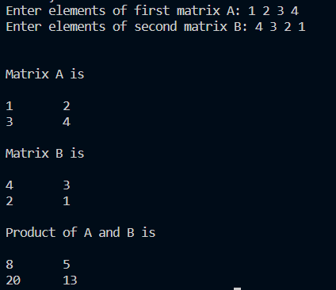
CONCLUSION: | Used Strassen’s Matrix Multiplication for a 2x2 matrix. We found that Strassen’s method has lesser time complexity than standard method for multiplication of square matrices.

